Youth Participation in Developing Sustainable Green Cities

2022-1-DE04-KA220-YOU-000085135

GreenCities WP3 – Units Outlined

Project Reference
Acronym: GreenCities
Title: “Youth Participation for Developing Sustainable Green Cities”
Programme: Erasmus + Programme of the European Union
Grant Agreement: “2022-1-DE04-KA220-YOU-000085135 - GreenCities”

Prepared by – Nikoletta Simon (KKKE)

Partnership

Lead Partner:
L4Y Learning for Youth GmbH – Germany

Partners:
Sdruzhenie Walk Together - Bulgaria
Cankaya Belediyesi - Turkey
Kaán Károly Környezetvédelmi Egyesület - Hungary
Kyttaro Enallaktikon Anazitiseon Neon KEAN - Greece
C.I.P. Citizens in Power - Cyprus

Unit 2:
2.7. Climate impacts, environmental protection, water management
Duration:

Teaching topic:
- definition of sustainable development, and its main principles
- climate impacts on environment
- renewable resources - water management

Learning Aims:
- To learn more about climate change, its impacts
- water management in short

  - Climate impacts, environmental protection, water management

The transition to sustainable development, the development of a green economy is a standard element of environment-related articles and conferences. The Stockholm Conference in 1972 laid the foundation of the modern environmental protection and defined its most important principles. In 1987, the United Nations - World Commission on Environment and Development (Brundtland Commission) published its report „Our Common Future”, which set out principles as well as the definition of sustainable development:
- Respecting and protecting communities
- Preserving biodiversity
- Improving the quality of human life
- Minimising the use of non-renewable resources
- Growth that respects the limits of the Earth's carrying capacity
- Changing individual behaviour and habits
- Motivating and empowering local communities to take care of their own environment
- Building national cooperation to develop sustainability strategies
- Global cooperation, agreements
This report also defined the concept of sustainable development: “meeting the needs of the present without compromising the ability of future generations to meet their own needs.”
This sustainable development is based on three pillars that do not exclude each other:
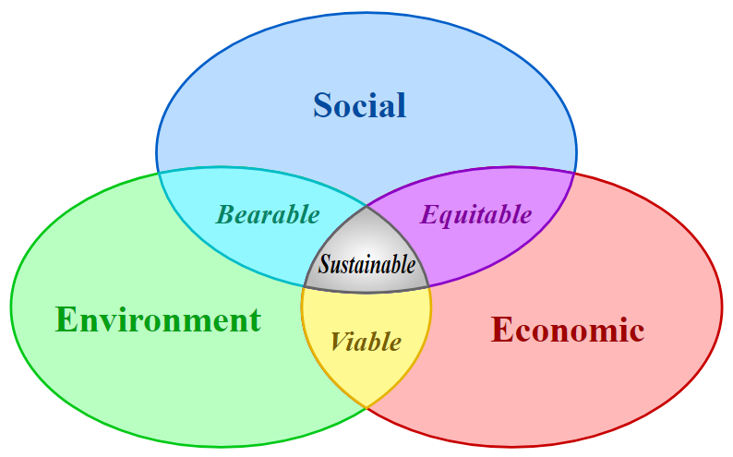
Source: https://www.arcweb.com/blog/three-pillars-sustainability-your-smart-city-project

Sustainability includes:
- The Preservation of Environmental Resources
- The Enhancement of Societal Goals – also known as ‘quality of life” or "safety" and,
- Economic Viability – since none of these goals can be accomplished without a sound, robust economic plan.
Today, the concept of sustainable development is integrated into national and global policies. Sustainability is a challenge for all countries. It is a long-term perspective for the environment, the economy, employment and social policy. In a global context, it is based on the responsibility of future generations, because climate change is a real problem and the main question is how we can adapt to it, how we can manage it.
Over the past decades, climate change has received the most social and political attention and interest, and it is one of the biggest problems of our time, and that is why there are already serious efforts at international and governmental levels to tackle the problem.
The main reason of climate change is the greenhouse effect. Some of the gases in the Earth's atmosphere act like the glass envelope of a greenhouse: they let in the sun's heat, but block it on its way back into space, causing global warming. Most of these greenhouse gases are naturally existing, but human activities have increased their concentrations, especially the following:
- carbon dioxide,
- methane,
- nitrous oxide,
- fluorinated gases.
Why is the concentration of greenhouse gases in the atmosphere increasing?
- The burning of carbon, oil and fossil gases produces carbon dioxide and nitrous oxide.
- Cutting down trees (deforestation): trees contribute to climate regulation by removing carbon dioxide from the atmosphere. So when they are cut down, this beneficial effect disappears.
- Animal husbandry: Large amounts of methane are produced by cattle and sheep during their digestion.
- Nitrogen-containing fertilisers generate nitrous oxide.
- Some equipment and products emit fluorinated gases into the atmosphere.
Cities and their inhabitants bear the greatest risk of global warming. The structure and structure of cities also mean that they are more exposed to the negative effects of climate change than much smaller settlements. The climate in cities is generally warmer, with rainfall, storms, etc.
These phenomena threaten the health, jobs and basic services of the people who live there. As a result, cities can also be economically weakened.
However, countries around the world do have climate strategies and background organisations to help address the problems of climate change in some way. All countries have a climate policy, with the two most important pillars being mitigation (reducing or absorbing emissions of greenhouse gases into the air) and adaptation.
In this context, the options for tackling the challenges caused by climate change can be divided into three main categories:
- mitigation – Reducing emissions, i.e. reducing the extraction and use of fossil fuels and increasing the share of renewable energy sources;
- adaption, adapting to the negative impacts of climate change
- raising awareness
As the urbanisation process has accelerated, the focus has turned to sustainability, as mentioned above. The concept of the green city has appeared, and more and more cities are examples of this. This concept is based on several principles. These include reducing and recycling waste, increasing green spaces and using renewable energy sources (water, wind, solar), which are increasingly playing a role in urban energy supply. In this chapter we focus on water management in detail.

Water energy, water management
Water is one of the oldest resources. Of the world's water, 97 percent is saltwater oceans, the remaining 69 percent is snow and ice. Freshwater in rivers, lakes and marshes, which is suitable for human consumption, contains only 0.008 percent of the Earth's water. Water is a commercial product as well as a public good. It is a limited resource that needs to be protected. Urbanisation is growing, driven by population growth and socio-economic development. It is necessary to adapt to this change, for example by developing infrastructure. Land-use change due to urbanisation is placing increasing pressure on these systems, and managing and operating them can lead to various challenges and problems.
The increased demand on water supplies due to urbanisation is in some cases leading to over-exploitation of water resources, causing water scarcity and water conflicts. Increased wastewater production overloads wastewater treatment plants, causing severe environmental pollution.
In addition, climate change is increasing the frequency and severity of extreme weather events (e.g. heavy rainfall), a risk that mainly affects water utility infrastructures.
For the most efficient use of water in cities, water supply, wastewater treatment, stormwater management and flood protection need to form a dynamic, interlinked system.
Climate protection efforts have enhanced the role of water energy. The Water Framework Directive (2000/60/EC) already provides for the protection of water resources, raising the need for smart planning of urban infrastructure, while integrated water management has an important role to play: for example, rainwater harvesting could partially cover water use within residential buildings. Several cities, such as Sydney and Singapore, have been working for several years to develop this type of flexible water management system on a large scale.
A brief summary of the main tasks of water management:
  - exploration, exploitation, extraction and distribution of water resources,
  - transporting water to the place of consumption,
  - water quality protection,
  - construction and operation of water facilities

Resources:
https://www.arcweb.com/blog/three-pillars-sustainability-your-smart-city-project
https://commission.europa.eu/eu-regional-and-urban-development/topics/cities-and-urban-development/priority-themes-eu-cities/circular-economy-cities_hu
https://konyvtar.uni-pannon.hu/images/docman-files/efop343/e-jegyzetek/Nemeth_Kornel_A_korforgasos_gazdasag_alapjai.pdf
https://climate.ec.europa.eu/climate-change/causes-climate-change_hu
https://lechnerkozpont.hu/cikk/varosok-a-klimavaltozas-viharaban
https://greendex.hu/mitigacio/
https://hu.euronews.com/2023/05/04/klimavaltozas-mit-tegyunk-hogy-varosaink-ne-valjanak-katlanna#vuukle-comments-2261858
https://www.ludovika.hu/blogok/ludeconblog/2022/04/18/a-varoslakok-megsinylik-a-klimavaltozast/
https://masfelfok.hu/2020/12/16/ut-a-vizerzekeny-varosokhoz-uj-szemlelet-a-varosi-csapadekviz-gazdalkodasban-iii-koppenhaga/
https://www.intervet.hu/zold-varosok-a-jovoben-hogyan-alakulnak-at-a-nagyvarosok/
https://real.mtak.hu/188070/1/Mrekva.pdf
https://tudasbazis.sulinet.hu/hu/szakkepzes/kornyezetvedelem-es-vizgazdalkodas/telepulesi-alapismeretek/telepulesek-halozatai/vizgazdalkodas

