UNIT 2: Thematic subsystems/pillars

Unit 2.6: Smart Living Conditions

Introduction

Smart living conditions are integral to the vision of sustainable green cities. This unit will explore the concepts, development, and strategies associated with creating smart living environments for enhanced well-being. Smart living conditions represent the integration of technology, sustainability, and design principles to create intelligent and adaptive urban environments. From energy-efficient buildings and smart infrastructure to innovative community spaces, the concept envisions a harmonious coexistence between residents and their surroundings. By leveraging advancements in technology, smart living aims to enhance the quality of life, promote sustainability, and foster a sense of well-being within urban communities.This unit explores the concepts, development, and strategies associated with creating smart living environments for enhanced well-being.

2. Sub-Topics

2.1 Introduction to Smart Living Conditions, Concept (Duration: 15 minutes)

Definition and Purpose:

- Define smart living conditions and their role in fostering sustainable urban living.

Smart living conditions involve the strategic integration of technology and sustainable practices to optimize urban living spaces. Their role is to enhance efficiency, reduce environmental impact, and elevate the overall quality of life for residents within cities, creating a foundation for sustainable and resilient urban living.

- Discuss the purpose and importance of creating intelligent living environments.

Creating intelligent living environments serves the fundamental purpose of optimizing human well-being within urban settings. By incorporating advanced technologies and sustainable design, these environments enhance comfort, safety, and connectivity for residents. The importance lies in fostering a harmonious relationship between individuals, their communities, and the urban landscape, ultimately contributing to a more resilient and sustainable future.

Visual Learning:

- Canva presentation and a short educational video to illustrate key concepts.

2.2 Development, and History of Smart Living Conditions (Duration: 15 minutes)

Evolution of Smart Living:

- Trace the historical development of smart living conditions and their impact on urban lifestyles.

The historical development of smart living conditions can be traced back to the emergence of urban planning concepts in the late 19th and early 20th centuries, focusing on improving living conditions in growing cities. However, the integration of advanced technologies became more prominent in the late 20th century with the rise of digitalization. The 21st century witnessed a transformative shift as smart technologies, IoT, and data analytics began to play a pivotal role in shaping intelligent living environments. This evolution has significantly impacted urban lifestyles, offering greater connectivity, energy efficiency, and convenience to residents, while also addressing environmental concerns. Today, smart living conditions continue to evolve, responding to contemporary challenges and striving to create urban spaces that prioritize sustainability and enhance the quality of life.

2.3 Key Components of Smart Living Conditions (Duration: 15 minutes)

Essential Components:

- Identify and explain the fundamental components contributing to smart living conditions.
- Discuss technologies and innovations that enhance the quality of life in urban settings.

Smart Infrastructure: Advanced infrastructure systems, including smart grids, efficient waste management, and integrated transportation networks, form the backbone of smart living conditions. These systems optimize resource usage and contribute to overall urban sustainability.

IoT Integration: The Internet of Things (IoT) plays a crucial role by connecting everyday devices and appliances. This connectivity enables data collection and analysis, allowing for real-time adjustments to enhance efficiency, convenience, and energy conservation.

Energy-Efficient Buildings: Intelligent building design integrates energy-efficient technologies, such as smart lighting, heating, and cooling systems. These features not only
minimize environmental impact but also contribute to cost savings for residents.

Smart Home Automation: Automation technologies, including smart thermostats, security systems, and appliances, provide residents with greater control over their living spaces.
This fosters a personalized and responsive environment that adapts to individual
preferences and habits.

Environmental Sustainability: Sustainable practices, including waste reduction, water conservation,and green spaces, are integral componentsof smart living conditions. These initiatives aim to minimize the ecological footprint of urban areas.

2.4 Benefits and Challenges (Duration: 10 minutes)

Examining Outcomes:

- Examine the benefits of smart living conditions, including improved comfort, energy efficiency, and community engagement.
- Discuss challenges associated with the implementation of smart living strategies.

- Smart living conditions offer multifaceted benefits that significantly enhance urban living. Improved comfort is achieved through technologies like smart thermostats, creating personalized and efficient home environments. Energy efficiency and community engagement are fostered through the integration of sustainable practices, smart infrastructure, and communal spaces, collectively contributing to a more comfortable, sustainable, and socially connected urban lifestyle.

- Challenges in implementing smart living strategies include the initial high costs of integrating advanced technologies and the need for comprehensive infrastructure upgrades. Additionally, ensuring data privacy and security poses a significant challenge, requiring robust measures to protect residents' information in the interconnected smart environments.

2.5 Case Studies: Successful Implementations (Duration: 15 minutes)

Real-World Examples:

- Showcase successful implementations of smart living conditions from diverse urban contexts.
- Analyze outcomes, challenges faced, and lessons learned from these case studies.

Successful implementations of smart living conditions refer to the effective integration and operation of various technological and sustainable strategies within urban environments, leading to positive outcomes for residents and the community. These implementations typically demonstrate improved quality of life, enhanced efficiency, and a positive impact on environmental sustainability. Key indicators of success include increased comfort, energy efficiency, streamlined services, and heightened community engagement, all contributing to a more livable and resilient urban setting. Success is measured by the tangible benefits experienced by residents, as well as the city's ability to adapt, innovate, and create a harmonious balance between technology and the well-being of its inhabitants.

1. Dubai's Smart City initiative aims to transform the city into a global leader in smart living. Implementation includes smart buildings, autonomous transportation, and innovative services like the Smart Dubai app, enhancing resident experiences through seamless government services, energy-efficient infrastructure, and
a holistic approach to urban development.

2. Barcelona's smart city initiatives focus on utilizing technology
to improve urban services and the quality of life for its residents.
The implementation of IoT sensors in public spaces, smart street
lighting, and a comprehensive urban mobility plan has enhanced
energy efficiency, reduced traffic congestion, and increased community
engagement, showcasing a successful integration of smart living strategies
in an existing urban context.

3. 3. Songdo, located near Seoul, is a smart city built from
the ground up with sustainability in mind. Equipped with
smart grids, sensor-based waste management, and an extensive
green transportation network, Songdo exemplifies how smart living
conditions can be integrated into new urban developments, offering
residents energy-efficient buildings, advanced healthcare facilities,
and smart public spaces.

3. Learning Aims

Objective Statements:

- Understand the concept and evolution of smart living conditions.
- Identify key components and technologies contributing to smart living environments.
- Evaluate the benefits and challenges associated with implementing smart living conditions.
- Analyze case studies to apply theoretical knowledge to practical examples.

- By 2023, it was estimated that the global smart home market would reach $53.45 billion
2. The number of connected devices globally was expected to surpass 30 billion by 2020.
3. Smart building solutions were projected to contribute to a 15-20% reduction in energy
consumption.
4. The global smart city market was projected to grow to $237.6 billion by 2025.
5. Smart city technologies were expected to reduce carbon emissions by 1.3 gigatons
by 2030.

4. Methodology

Engagement Methods:

- Videos for different sub-topics :

5. Materials

- Canva presentation, videos
- Laptop or Smartphone

References:

https://www.techtarget.com/iotagenda/definition/smart-home-or-building

https://encyclopedia.pub/entry/52230

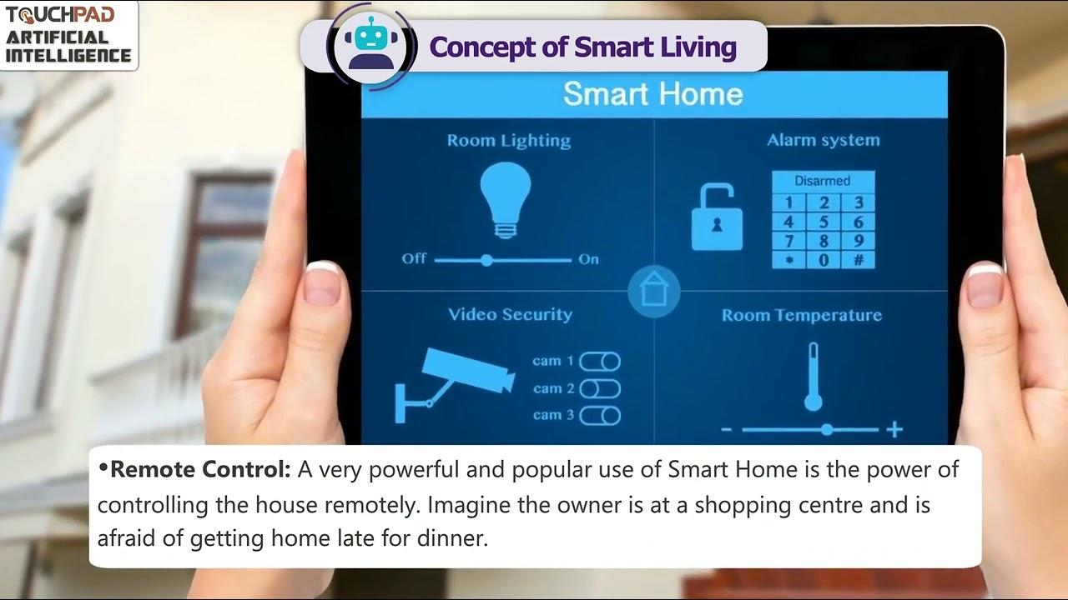

VIDEO: https://www.youtube.com/watch?v=E9UbQdQZ6tc&t=3s

